Lab SHEET 04
(FULL STACK)
HIMANI CHAUDHARY , BTECH(CSE), CU240250967 (24) ,
SEC (B)
Task 1: Custom Module
const fs = require("fs");
const path = require("path");
const os = require("os");
const http = require("http");
const url = require("url");
const EventEmitter = require("events").EventEmitter;
// TASK 1: CUSTOM MODULES
function sum(a, b) {
return a + b;}
function evenOdd(num) {
return num % 2 === 0 ? "Even" : "Odd";}
console.log("\n===== TASK 1 =====");
console.log("Sum:", sum(10, 20));
console.log("7 is:", evenOdd(7));
console.log("12 is:", evenOdd(12));
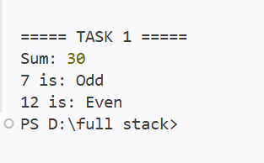
// // TASK 2: FILE SYSTEM
console.log("\n===== TASK 2 =====");
fs.writeFileSync(
"student.txt",
"Name: Himani\nRoll No: 101\n"
);
fs.appendFileSync(
"student.txt",
"Course: Full Stack Web Development\n"
);
console.log("File Content:");
console.log(fs.readFileSync("student.txt", "utf8"));
if (fs.existsSync("profile.txt")) {
fs.unlinkSync("profile.txt");
}
fs.renameSync("student.txt", "profile.txt");
console.log("student.txt renamed to profile.txt")
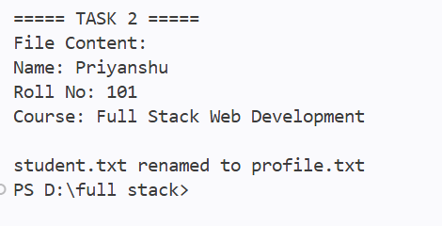
// // TASK 3: DIRECTORY OPERATIONS
console.log("\n===== TASK 3 =====");
if (!fs.existsSync("uploads")) {
fs.mkdirSync("uploads");
}
fs.writeFileSync("uploads/file1.txt", "");
fs.writeFileSync("uploads/file2.txt", "");
fs.writeFileSync("uploads/file3.txt", "");
console.log("Files created:");
console.log(fs.readdirSync("uploads"));
if (fs.existsSync("uploads/file3.txt")) {
fs.unlinkSync("uploads/file3.txt");
}
console.log("file3.txt deleted.");
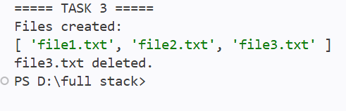
// TASK 4: PATH MODULE
console.log("\n===== TASK 4 =====");
const filePath = "/home/user/data/report.pdf";
console.log("Directory:", path.dirname(filePath));
console.log("Base Name:", path.basename(filePath));
console.log("Extension:", path.extname(filePath));
console.log(
"Absolute Path:",
path.resolve("./data/report.pdf")
);
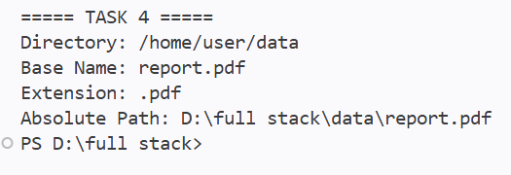
// TASK 5: OS MODULE
console.log("\n===== TASK 5 =====");
console.log("Platform:", os.platform());
console.log("Architecture:", os.arch());
console.log(
"Total Memory:",
(os.totalmem() / 1024 / 1024 / 1024).toFixed(2),
"GB");
console.log(
"Free Memory:",
(os.freemem() / 1024 / 1024 / 1024).toFixed(2),
"GB"
);
console.log("CPU Cores:", os.cpus().length);
console.log(
"System Uptime:",
(os.uptime() / 60).toFixed(2),
"minutes"
);
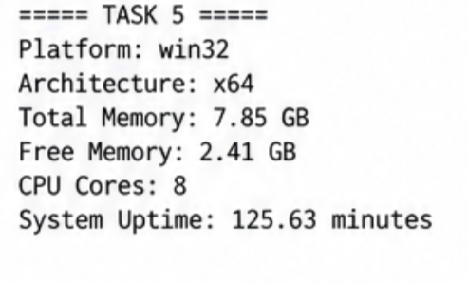
// TASK 6: EVENTS MODULE
console.log("\n===== TASK 6 =====");
const orderEmitter = new EventEmitter();
orderEmitter.on("orderPlaced", (order) => {
console.log("\n===== ORDER RECEIPT =====");
console.log("Order ID:", order.id);
console.log("Item:", order.item);
console.log("Amount: ₹" + order.amount);
console.log("=========================");
});

orderEmitter.emit("orderPlaced", {
id: 101,
item: "Laptop",
amount: 55000});
orderEmitter.emit("orderPlaced", {
id: 102,
item: "Mouse",
amount: 800});
orderEmitter.emit("orderPlaced", {
id: 103,
item: "Keyboard",
amount: 1500});
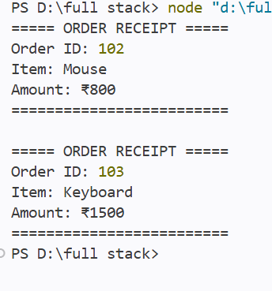
// TASK 7 & 8: HTTP SERVER + QUERY STRING
console.log("\n===== TASK 7 & 8 =====");
const students = [{
id: 1,
name: "Rahul",
course: "B.Tech" },
{ id: 2,
name: "Priyanshu",
course: "BCA"},
{ id: 3,
name: "Aman",
course: "MCA” }];
const server = http.createServer((req, res) => {
const parsedUrl = url.parse(req.url, true);
const pathname = parsedUrl.pathname
// HOME
if (req.method === "GET" && pathname === "/") {
res.writeHead(200, {
"Content-Type": "text/html"});
res.end(
"<h1>Welcome to Node.js Server</h1>" ); }
// ALL STUDENTS
else if (
req.method === "GET" &&
pathname === "/students"
) {
res.writeHead(200, {
"Content-Type": "application/json"
});
res.end(JSON.stringify(students));}
// STUDENT BY ID
else if (
req.method === "GET" &&
pathname.startsWith("/students/")
) {
const id = parseInt(
pathname.split("/")[2]
);

const student = students.find(
s => s.id === id);
if (student) {
res.writeHead(200, {
"Content-Type": "application/json });
res.end(JSON.stringify(student));

} else {
res.writeHead(404, {
"Content-Type": "application/json"
});
res.end(JSON.stringify({
error: "Student not found}));
// SEARCH
else if (
req.method === "GET" &&
pathname === "/search"
) {
const keyword =
parsedUrl.query.keyword || "";
res.writeHead(200, {
"Content-Type": "text/plain"
res.end(
"Search Keyword: " + keyword
);
// 404
else {

res.writeHead(404, {
"Content-Type": "text/html"
});
res.end(
"<h1>404 - Page Not Found</h1>"
));
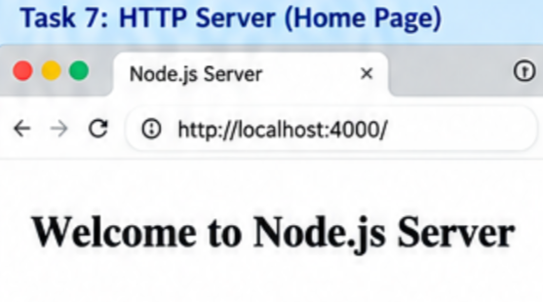

// TASK 9: STREAM
console.log("\n===== TASK 9 =====");
let data = "";
for (let i = 1; i <= 50; i++) {
data += "This is line number " + i + "\n";}
fs.writeFileSync("large-file.txt", data);
console.log("50 lines created.");
const stream = fs.createReadStream(
"large-file.txt");
stream.on("data", (chunk) => {
console.log(
"Chunk received:",
chunk.length,
"bytes"
);
});

stream.on("end", () => {
console.log(
"File reading completed."
});
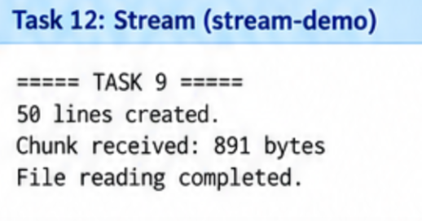

// TASK 10: NANOID
console.log("\n===== TASK 10 =====");
try {
const { nanoid } = require("nanoid");
for (let i = 1; i <= 5; i++) {
console.log(
"ID " + i + ":",
nanoid()
);
}
} catch (error) {
console.log(
"Run: npm install nanoid@3"
);}
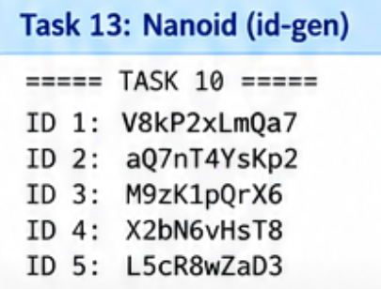

// TASK 11: COMMAND LINE CALCULATER
console.log("\n===== TASK 11 =====");
const num1 = Number(process.argv[2]);
const num2 = Number(process.argv[3]);
const operator = process.argv[4];
if (!isNaN(num1) &&
!isNaN(num2) &&
operator
) {
let result;
switch (operator) {
case "+":
result = num1 + num2;
break;
case "-":
result = num1 - num2;
break;
case "*":
result = num1 * num2;
break;
case "/":

if (num2 === 0) {
console.log(
"Cannot divide by zero.");
Break};
result = num1 / num2;
break;
default:
console.log(
"Use +, -, * or /"
);
if (result !== undefined) {
console.log(
`${num1} ${operator} ${num2} = ${result}`
);}

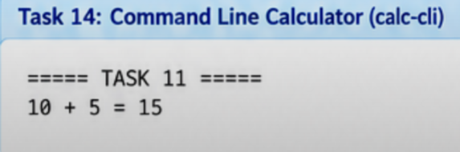
// TASK 12: ENVIRONMENT VARIABLE
const PORT = process.env.PORT || 4000;
server.listen(PORT, () => {
console.log("\n===== TASK 12 =====");
console.log(
"Server running on port:",
PORT
);
console.log(
"Open: http://localhost:" + PORT
);
console.log(
"Search: http://localhost:" +
PORT +
"/search?keyword=node"
);
});
